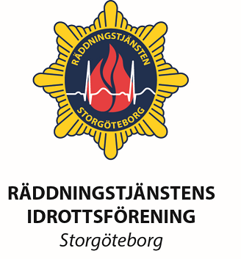
Invitation to Nordiska Brandmästerskapen 2018
- Soccer
- 5 km & 10 km Terrain Running
- Floorball
- Social event - Boule

Program
Tuesday 28 August - Arrival
Check in & Welcome Bag at Serneke Hotel Kviberg 10-17
Friendly evening with light grill at Gårda Fire Sation 18-21
Meeting for Representives at Gårda kl. 19.00
Suggestions or rule changes for the meeting should be sent to erik.skapdal@rsgbg.se before may 31th
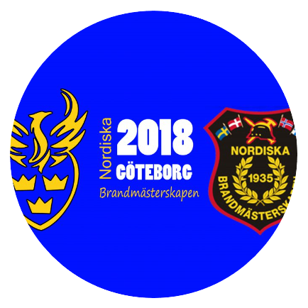
Wednesday 29 August
Soccer 09.00-16.00
Floorball 09.00-16.00
Running 10.00
Thursday 30 August
Soccer semifinals - 09.00
Boule tournament 09.00
Floorball semifinals - 09.00
Floorball final - 13.00
Soccer final - 14.00
Banquet in town at 19.00
Friday 31 August - Travel Home

Contact
http://www.rifgbg.se/nordiska/

Chairman & Accomodation
Erik Skåpdal Mobil: +46 704415677 Mail: erik.skapdal@rsgbg.se

Soccer
Erik Skåpdal Mobil: +46 704415677 Mail: erik.skapdal@rsgbg.se

Floorball
Jakob Söderberg Mobil: +46 703058643 Mail: jakob.soderberg@rsgbg.se

Terrarin 5 km og 10 km:
Tina Laas Mobil: +46 762502957 Mail: tina.laas@rsgbg.se

Boule:
Reidar Johansson Mobil: + 46 705382657 Mail: reidarjohansson1010@gmail.com

Accomodation

You contact the hotel and make you own reservation. Don´t forget to mention the “Nordiska Brandmästerskapen” to get the right price. Please have a complete list of names put together if they ask. Pay is upon arrival or check-out.

First Hotel Kviberg
Address: Krutvägen 2
41528 Göteborg
Phone: 010-2506400
https://www.firsthotels.se/hotell/sverige/goteborg/first-hotel-kviberg-park/
http://www.prioritetsernekearena.se/

- Included: Breakfast, Free Wi-Fi, Bastu/Sauna & Jacuzzi
- 10 minutes with tram to Central Gothenburg
- Nordic Wellness Gym (4000m2), Skidome inside 1,2km, Intersport Shop, Beach Volley and indoor climbing centre next door.
- Lunch restaurant, Dinner Restaurant, Ski Lodge snack bar & Sports Bar
- Long time Parking outside the hotel

You have the following options (prices is for all 3 nights per person)

Double room - 1500 SEK - Total 24 rooms booked for Nordiska
3 bed room - 1200 SEK - Total 14 rooms booked for Nordiska
4 bed room - 1125 SEK - Total 40 rooms booked for Nordiska

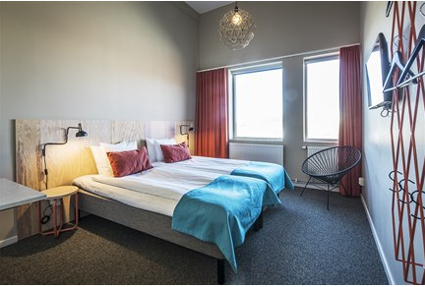

Notification

Send notification to erik.skapdal@rsgbg.se before 2018-05-10

Your checklist
- A mail to Erik including:
  - Name of all competitors and what sports they participate to Erik
  - Number of bus tickets, if you want zero/none, tell me also
  - Your way of transportation and if you know when you arrive/leave
- Pay the fees to the RIF Gothenburg bank account
- Book your accommodation

Fee
The fee is set to 122EUR / competitor, leader & tourist.
That includes competition, airport/train pickup, welcome evening grill, banquet, welcomebag

Competitor fees + Bustickets --> Account:
Bankkontonr: 9960 2606267512
BAN: SE91 9500 0099 6026 0626 7512
BIC-kod (SWIFT-adress): NDEASESS
Kontohavare: BRANDKÅRENS IDROTTSFÖRENING
ÅBY ALLÈ 25
43145 MÖLNDAL

Pre order Bus Tickets
You have the possibility to pre-order tickets for 3 days and get them when you arrive at the Hotel in the welcome bag. The price is 20 EUR for 3 days card. You could also use them to take a ferry in the archipelago.

If you decide to not buy this card you could easily use the Västtrafik To Go App and buy single tickets for around 2EUR.
https://itunes.apple.com/se/app/vasttrafik-to-go/id424903083?mt=8
https://play.google.com/store/apps/details?id=com.vaesttrafik.vaesttrafik&hl=sv

Boule - Social Arrangement

Boule will be played as a tournament on one day. Not all rules are set

Names Below City

Soccer Team Rooster

Town:

Color of shirt:
NR: | Player
1
2
3
4
5
6
7
8
9
10
11
12
13
14
15
16

Coach | EVT: MOBIL TELEFON

This should be hand in to the Tournament leader before the first game

Running

5 km or 10 km Terrain Running

Classes
- Open Women
- Open Men
- 35-39
- 40-49
- 45-49
- 50-54
- 55-59
- 60 <

Family Name First Name Class
1
2
3
4
5
6
7
8
9
10
11
12
13
14
15
16

Floorball

Town:

Color of shirt:
NR: | Player
1
2
3
4
5
6
7
8
9
10
11
12

Coach | EVT: MOBIL TELEFON

This should be hand in to the Tournament leader before the first game

